**A Pilot Program to Engage Medical Students in Communication with Primary Care Patients through the Patient Portal**

Abraham Z. Cheloff, MD, MS*1, Katherine C. Wrenn, MD*2,3, Garret M. Johnson MD4, Nicholos P. Joseph2, Leonor Fernández, MD2,3, Jennifer L. Cluett, MD2,3, Gila R. Kriegel, MD2,3, and Amy R. Weinstein, MD, MPH2,3

* the denoted authors both completed the work typical of the first author

1. NYU Langone Health, New York City, New York
2. Harvard Medical School, Boston, Massachusetts
3. Beth Israel Deaconess Medical Center, Boston, Massachusetts
4. Duke Medical Center, Durham, North Carolina

**Address correspondence to**:

Abraham Z. Cheloff, M.D., M.S.

[abraham.cheloff@nyulangone.org](mailto:abraham.cheloff@nyulangone.org)

Problem

Innovations in electronic communication through patient portals and open notes can give patients easier electronic access to their physicians and medical records. Use of these portals for secure messaging is on the rise; between 2001 and 2010, the number of online patient messages received by U.S. physicians nearly tripled (1), despite mixed opinions and uneven uptake by faculty and residents (2). While patient portals and electronic messaging may improve patients’ access to their primary care team, virtual triage systems are not always fully developed, and do not parallel the more robust telephonic system of triage. Research suggests that physician messaging is not very patient-centered (3), and more effective interventions are needed to improve patient messaging systems’ utility (4). Furthermore, medical education must continually adapt to these new technologies in order to prepare trainees for future practice.

As patient participation in messaging grows, managing electronic communication with patients will be an increasingly important part of a physician's duties (1), and therefore important to medical education. In the same way that medical students need to develop a clinical “voice” and vocabulary for speaking with and treating patients in person, they also need to develop the ability to communicate effectively with patients online. While simulation has shown that student interaction with patients via email can strengthen these skills (5), to date there have not been published studies describing actual engagement of medical students in direct patient messaging. There is sparse literature about establishing this type of curriculum for residents (6). Medical student participation in electronic communication with patients, under faculty supervision, would provide a novel educational opportunity for students to develop these important clinical skills early in their training.

Medical student participation in such programs may promote benefits beyond developing concrete clinical writing and communication skills. Participation of medical students in triage programs has been shown to increase student acquisition of clinical knowledge as well as improve communication with attendings and residents (7). More practically, there is a growing recognition and body of evidence regarding value-added care roles through which medical students (8), may augment their medical education and add meaning to the care that they provide.

With the COVID-19 pandemic acting as a catalyst that forced medical educators to shift curricula quickly to virtual platforms, our team identified an opportunity to conduct a pilot program for medical students to engage directly in electronic communication with patients. In this Innovation Report, we describe the approach taken at Beth Israel Deaconess Medical Center (BIDMC), to keep medical students engaged with direct patient care through participation in electronic patient messaging during the COVID-19 pandemic.

Approach

*Implementation*

This pilot project occurred over 8 weeks between March and June 2020, coinciding with the first wave of the COVID-19 pandemic in Boston. Students were selected on a volunteer-basis to participate in the pilot, and all had completed at least half of their core clinical rotations. Each of the 4 students included in the project was paired with an internal medicine faculty member at Healthcare Associates (HCA), the primary care practice based at BIDMC, a large academic teaching hospital in Boston, Massachusetts. These faculty members included both full-time and part-time clinicians.

“PatientSite” is BIDMC’s proprietary patient portal for communication between health professionals and patients. The portal offers different triaging functions for patients, allowing requests such as medication renewals or obtaining referrals to be sent directly to the appropriate staff. However, many patients send emails via the PatientSite portal directly to their physicians with a variety of concerns and may not always understand how to use these triaging functionalities. Patients are advised to use PatientSite for non-urgent health questions or concerns and are instructed to call the office for any acute clinical issues. As of today, over 60% of patients in HCA are signed up for PatientSite, and this number continues to increase steadily.

As part of this pilot, each faculty member’s PatientSite messages were forwarded to their respective students, and students were tasked with replying to and directing messages in the portal to the appropriate entities at least once daily. Categories were created to track the different types of messages being received (Table 1). These categories were determined prior to initiation of the project, reassessed periodically, and modified using a rapid cycle improvement approach. For instance, it was determined that distinguishing between messages requiring coordination from only the attending physician vs. the attending physician and other support staff was necessary, and the change was made to document this accordingly. Best practices from each student-faculty pairing were factored into the determination of these categories.

*Criteria for success*

The primary goal of this project was to provide educational value for participating students. As such, understanding workflow in the primary care practice, the types of PatientSite messages received, and knowing where to refer to these messages were skills needed to fulfill the duties of this project. Over the course of the pilot, the goal was to grant increasing latitude to each student in decision-making as they became accustomed to workflow, operations, and provider preferences. Further, with the proliferation of telehealth across the nation, developing a place for patient portal management in telehealth education in future clerkships was assessed.

Outcomes

To expand on previous studies that have described the use of simulated patient messaging in medical school curricula (5, 9), this is the first report to describe student interactions directly with patients in the setting of online messaging. We add new data on the types of messages to which students could be expected to respond in an adult primary care setting, as well as reflections on the educational value of this program from participating students.

*Better understanding types of PatientSite messages*

During the eight-week pilot, students responded to 399 unique messages, not including replies regarding the same issue. On average, each student responded to 14 messages per five-day week. Including replies, students responded to 859 total messages.

Messages were categorized into one or more categories depending on the subject. The majority of messages (52 percent) concerned non-urgent clinical concerns, such as patients sending in their home blood pressure readings, asking questions about minor symptoms, medication side effects and specialist referrals. Urgent clinical issues requiring same-day follow-up made up 10 percent of messages. Similarly, 11 percent of messages related to COVID-19; these messages ranged from questions about symptoms to requests for testing and guidance on social distancing. 11 percent of messages were related to scheduling telehealth or in-person appointments. Finally, 4 percent of messages involved prescriptions, refills, and/or prior authorization (Figure 1).

*Educational value*

All participating students felt that the project was a valuable exercise for their medical education. The major skills that students identified as building during this pilot were: triaging patient concerns, coordinating specialist care, labs, and social needs, and communicating with patients about COVID-19.

While the PatientSite system was designed for non-urgent health issues and includes a banner reminder not to use email for urgent issues, patients occasionally wrote with concerns requiring immediate care (e.g. acute dyspnea). In addition, the quality and amount of history provided in patient messages was highly variable. For instance, some patients described their symptoms in detail and even provided pertinent negatives, while others provided just a few words of description (“I had some aches and chills”). Students were advised to call or text their attending if a message required immediate attention, and in general they felt that their clerkships had prepared them well to understand which concerns were urgent. Nonetheless, all participating students reported that the project improved their ability to understand when to alert their attending for urgent concerns. Students felt most comfortable responding to routine, common issues such as hypertension management, and ultimately developed systems for responding to “frequently asked questions.” For example, one student-attending pair developed standardized language regarding home blood pressure measurement to receive more accurate, actionable data.

Students also reported gaining a better understanding of how to efficiently coordinate care using electronic messages. Patients frequently used PatientSite to request specialist care, lab tests, or social issues (e.g. financial assistance with prescription costs). Students were able to build skills in communicating with subspecialists, understanding which tests and imaging to order in given clinical situations, and connecting patients with community resources.

Patients frequently wrote in with questions about COVID-19 ranging from concerns about their own symptoms to requests for molecular and serologic testing. Because of the dynamic nature of the pandemic at the time of the pilot, attendings kept students apprised of the latest protocols for testing, as well as the latest guidance on triaging suspected COVID-19 patients, which they communicated to patients. The project allowed students both to build their understanding of the novel disease and build the skill of translating new and confusing scientific information into understandable terms for patients.

Finally, the project offered students an opportunity to develop online communication skills. In the same way that that attendings might model and students might practice their verbal communication skills in a clinic setting, this experience allowed students to note how attendings “spoke” with patients on email, and to develop their own online clinical “voice.” Both students and attendings noted that students are very rarely asked to write letters to patients as part of a clerkship, and felt that this pilot helped to improve students’ written communication skills.

*Contributing to the COVID-19 response*

While the primary goal of this pilot was educational, students hoped that their work might alleviate some of the burden facing primary care physicians during the COVID-19 pandemic. Most attendings felt that the pilot reduced their work, but at least one felt that, especially at the beginning of the pilot, it added to their work. One participating attending called the students’ involvement “extremely helpful” and said that the project “saved me so much time.”

*Attending perspectives*

Attendings believed that a more systematized, formally integrated PatientSite clerkship or mini-clerkship had the potential to save them more time in the future and improve their ability to assess, teach and model medical student communication skills. Several attendings noted that staying connected to students and teaching during the pandemic, when most educational activities had ceased, was beneficial for their well-being. Moreover, patient messaging inherently allows more flexibility in teaching, which multiple attendings noted as a beneficial aspect of this project. One attending said that “being able to do more asynchronous teaching and patient care added flexibility and expanded the amount of time I was able to work with the student.”

Next Steps

This pilot program, while involving only a small group of students, provides a basis for broader implementation of a similar program at other institutions and other points in medical education. The educational value provided reflects many of the competencies necessary to graduate from medical school. These virtual interactions could be integrated into core clerkship curricula in Internal Medicine, Pediatrics, Family Medicine, Primary Care, or any rotation involving an outpatient experience. Assigning a “tele-preceptor,” who would ideally be the same preceptor that oversees the student in the clinic, would allow students to engage in the full spectrum of a primary care relationship and gain a deeper understanding of the patient-physician relationship outside of the traditional, in-person encounter. Alternatively, in the interest of increasing student wellness given ongoing disruption to learning caused by COVID-19, students could be assigned one or more “virtual weeks,” in which their responsibility is to triage and respond to patient messages. This would allow them to interact with a greater number and diversity of patients than they would in a single clinic session, while also providing flexibility to address personal issues during clerkships. As telehealth expands in the post-COVID-19 world, medical schools could even consider an elective in telemedicine.

Furthermore, given that the skills learned in this experience were not specific to advanced students, such a project could be extended to preclinical students as well. In the preclinical years, students often spend time with outpatient preceptors learning the basic history and physical exam. Including some aspects of remote care, such as participating in patient messaging, may help preclinical students build their communication and interpersonal skills, as well as gain a better understanding of care coordination and patient needs before beginning the core clerkships. Furthermore, developing a medical vocabulary and voice in communication with patients develops the core competence of interpersonal and communication skills; early, concerted, mentored practice can facilitate this process. In future iterations, it would be helpful to expand the number of pairings to get more diverse feedback in the process.

While this pilot program was only an initial attempt to incorporate patient messaging into medical education, its impact and workability are promising. Integrating patient messaging into medical school curricula is an important first step in modernizing medical education and preparing our trainees to be effective 21st century physicians.

**Acknowledgments:** The authors wish to thank Dr. Felipe Molina, Dr. James Heckman, and Dr. Sophia Meyerson for their participation and support throughout this project.

**References**

1. Crotty, B.H., et al., *Patient-To-Physician Messaging: Volume Nearly Tripled As More Patients Joined System, But Per Capita Rate Plateaued.* Health Affairs, 2014. **33**(10): p. 1817-1822.

2. Keplinger, L.E., et al., *Patient portal implementation: resident and attending physician attitudes.* Fam Med, 2013. **45**(5): p. 335-40.

3. Hogan, T.P., et al., *Patient Centeredness in Electronic Communication: Evaluation of Patient-to-Health Care Team Secure Messaging.* J Med Internet Res, 2018. **20**(3): p. e82.

4. Elston Lafata, J., et al., *Patients' adoption of and feature access within electronic patient portals.* Am J Manag Care, 2018. **24**(11): p. e352-e357.

5. Christner, J.G., et al., *Use of simulated electronic mail (e-mail) to assess medical student knowledge, professionalism, and communication skills.* Acad Med, 2010. **85**(10 Suppl): p. S1-4.

6. Crotty, B.H., A. Mostaghimi, and B.E. Landon, *Preparing residents for future practice: report of a curriculum for electronic patient-doctor communication.* Postgrad Med J, 2013. **89**(1056): p. 554-9.

7. Chen, J.Y. and P.J. Lewis, *The value of a medical student radiology triage program in enhancing clinical education and skills.* Acad Radiol, 2014. **21**(7): p. 829-33.

8. Gonzalo, J.D., et al., *Adding Value to the Health Care System: Identifying Value-Added Systems Roles for Medical Students.* Am J Med Qual, 2017. **32**(3): p. 261-270.

9. Barnhart, A., et al., *Electronic health communication: an educational application for this principle of the Patient-centered Medical Home.* Fam Med, 2010. **42**(5): p. 322-6.

**Table 1: Categories of messages received**

|  |  |
| --- | --- |
| **Select one of the below** | **Select all that apply** |
| Urgent clinical questions (PCP only) | Scheduling/Forms |
| Urgent clinical questions (PCP + Support Staff) | Triage |
| Non-urgent clinical questions (PCP only) | Community resource aid |
| Non-urgent clinical questions (PCP + Support Staff) | Prescriptions |
|  | Prior authorizations |
|  | COVID-19 related |
|  | Left for resident |
|  | Left for attending physician or staff copied on message |

Caption: Each message was categorized by one of the four options in the first column and by as many designations as appropriate from the second column.

**Figure 1: Types of messages received during pilot**

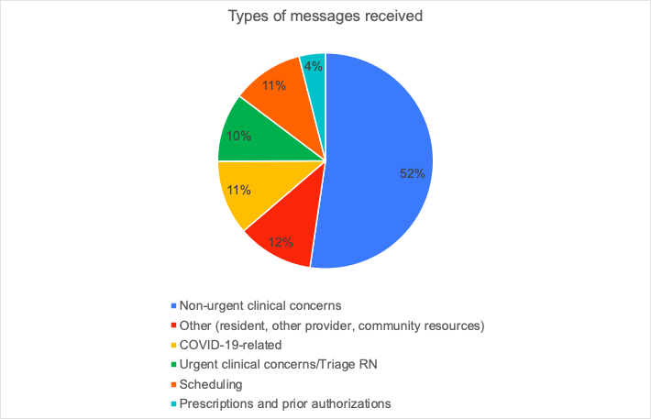

Caption: Percentage breakdown of messages received on the portal by categories determined.

**Figure 2: Operational Workflow**

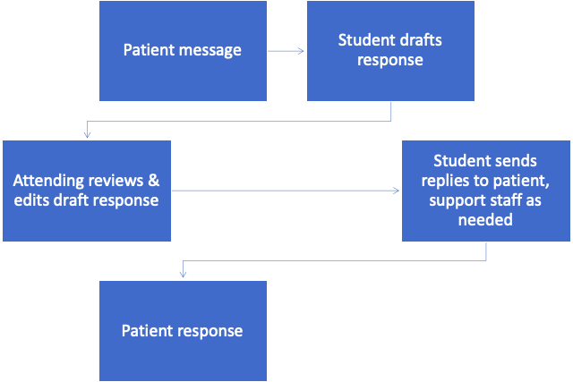

Caption: Visualization of operational workflow for each message received on the PatientSite portal. Students were expected to check the patient portal at least twice per day, and messages received a reply within one business day.