Diagnostic Safety Toolkit: Activity Two
Discuss Institutional Approach and Patient Vignettes
After identifying the shared goals and guiding principles, the core team will begin looking at their institutional diagnostic testing follow-up practices.

Institutional Approach Questions
The purpose of starting with a set of broad questions is to provide a prompt for team members to discuss their overall impression of diagnostic safety issue at your institution, and provide context for this project.
Institutional Approach
- What areas of diagnostic testing follow-up would you describe the system as highly reliable within your institution?
- Where do you see system vulnerabilities?
- Who are the key stakeholders in ensuring high reliability in diagnostic testing follow-up?
- In addition to identifying stakeholders, what other supports (administrative, FTE support, external and internal grants) are needed to make changes to the process?

After discussing the broad questions, the core team will view and discuss specific patient scenarios as though the situation were happening at your institution.
The intent of the vignettes is to help understand your institution’s current state of post-discharge test follow-up practices. The issues brought forth in the vignettes will assist in identifying the current practices in: “Activity Three: Conduct an Institutional Inventory: Current Communication Processes and Practices.”
Note: There will likely be a need to engage with others at your institution to answer the questions in the vignettes. This can be a designated action item after this initial meeting.

Facilitating the Vignette Discussions
- When discussing the vignettes, remind your team to view the stories as though they’re occurring at your institution and to consider the current practices and procedures where they work.
- There are four vignettes, each with their own set of specific discussion/learning questions.
  - With each vignette there are also two summary questions, providing participants the opportunity to identify common problems and communication gaps in the post-test patient follow up.
  - Depending on the size of the group or other considerations, you may opt to discuss some or all of the four vignettes during a single or multiple sessions.
  - Another option is to discuss the vignettes at an appropriate point during the seven steps of “Activity Three: Conduct an Institutional Inventory: Current Communication Processes and Practices.”
- Convene the vignette discussions either in-person or via video conference.
- Suggestions for how you may want to prepare for and organize the discussions.
  - Provide the vignettes and questions to team members ahead of time.
  - Use the vignette-specific questions, as well as the summary questions, as prompts for thinking through the diagnostic follow-up processes currently in place at your institution.
  - Explain to discussion participants that the questions are designed to uncover gaps.
- The following are provided as part of this toolkit:
  - A PowerPoint deck of three slides for each of the vignettes:
    - Text of the vignette, along with a patient image.
    - Questions specific to the vignette.
    - Summary questions (same for each vignette).
  - A copy below (one vignette per page) with space for capturing answers, which can be filled in electronically, or printed and handed out. You may choose to designate someone to record the answers.
- Remind participants that the questions are designed to uncover gaps at your institution, and the final activity, “Develop an Action Plan,” will focus on what can be done to eliminate or mitigate those gaps.
- Optional Approaches:
  - Divide participants into small groups, with each working on a different vignette (in-person or via breakout rooms within the virtual platform). If you divide people into small groups, please ensure broad representation within each group.
  - Convene as a large group to debrief, with small groups reporting the highlights of their discussion.

Vignette 1: Patient Primary Care Provided Outside Your System
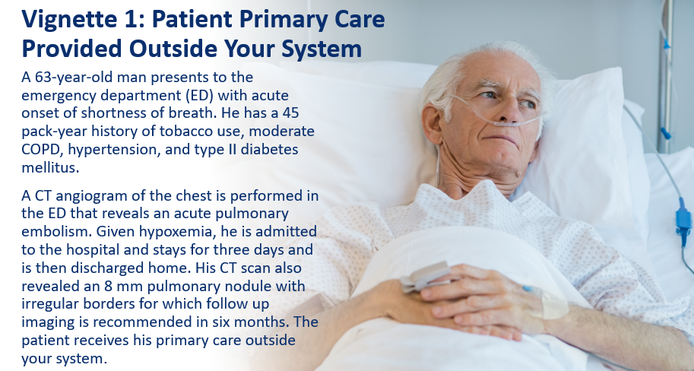
  - Who are the key participants that need to be involved in patient follow-up?
  - How likely do you think it is that the acute care team members are aware of the nodule?
  - How likely do you think it is (in the present state) that the nodule and need for follow-up will be shared with the patient?
  - Who is notified of the nodule at the time of discharge?
  - How will the acute care providers, or other appropriate providers, be made aware if proper follow-up doesn’t occur?
  - What system(s) exist to ensure that proper follow-up occurs?
  - How would this differ if the patient’s primary care provider is in the system? What if they had no primary care provider?
  - List the sources/resources you would need to contact to receive the answers to these questions.
  - Of the sources and resources listed, what is missing in the processes at your institution?

Vignette 1: Patient Primary Care Provided Outside Your System - Summary Questions
Summary Questions:
  - What common problems were identified in the vignette?
  - What gaps were identified in your institution’s processes while working through this vignette? (Keep these gaps in mind. The final activity of this project is to develop a plan to address gaps.)

Vignette 2: Referred to Internal Medicine
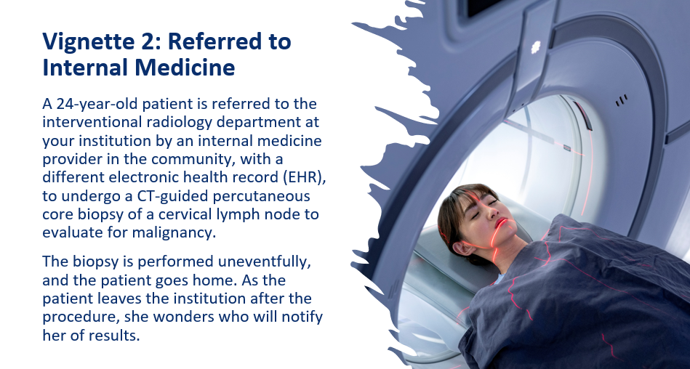
  - How does the communication of results differ if the biopsy is positive or negative? Should it?
  - How, and to whom, are these results communicated?
  - What systems are in place to ensure that appropriate follow-up has occurred?
  - Who is responsible for ensuring this follow-up and communication have occurred?

Vignette 2: Summary Questions
  - What common problems were identified in the vignette?
  - What gaps were identified in your institution’s processes while working through this vignette? (Keep these gaps in mind. The final activity of this project is to develop a plan to address gaps.)

Vignette 3: Toddler in ED

  - Who would receive the information about this elevated creatinine level? How would it be transmitted?
  - How likely do you think it is that the family would receive this information?
  - How would follow-up systems differ if the patient did or did not receive primary care within your health system? If patient had no primary care provider?
  - What systems are in place to ensure that follow-up occurs?

Vignette 3: Summary Questions
  - What common problems were identified in the vignette?
  - What gaps were identified in your institution’s processes while working through this vignette?

Vignette 4: Pending Labs After Discharge

  - Will the information about the EBV viremia be contained in the discharge summary?
  - How likely do you think it is that the patient would receive this information?
  - Who is responsible for arranging appropriate follow-up testing?
  - Who would be notified if follow-up does not occur?

Vignette 4: Summary Questions:
  - What common problems were identified in the vignette?
  - What gaps were identified in your institution’s processes while working through this vignette? (Keep these gaps in mind. The final activity of this project is to develop a plan to address gaps.)

