Diagnostic Safety Toolkit: Facilitator’s Discussion Guide
Diagnostic Safety Toolkit: Preface 1
Introduction to the Toolkit 1
Acknowledgments 3
Activity One: Getting Started 5
Steps for Using This Toolkit 5
Goals and Objectives 5
Convene a Core Team 5
Hold a Kickoff Meeting of the Core Team 6
Activity Two: Discuss Institutional Approach and Patient Vignettes 7
Institutional Approach Questions 7
Facilitating the Vignette Discussions 8
Vignette 1: Patient Primary Care Provided Outside Your System 9
Vignette 2: Referred to Internal Medicine 11
Vignette 3: Toddler in Emergency Department 12
Vignette 4: Pending Labs After Discharge 13
Activity Three: Conduct Institutional Inventory: Current Communication Processes and Practices 14
Step 1: Identify the Assessment Team 14
Step 2: Recognize and Discuss Current Successes 16
Step 3: Document Legal and Accreditation Requirements 17
Step 4 Categorize Results 18
Step 5: Identify Communication Practices for Various Follow-Up Scenarios 19
Step 6: Document Communication Practices and Procedures 20
Step 7: Determine the Level of Institutional Support 21
Activity Four: Reflection and Action Guide 22
Reflect Upon Your Work Thus Far 22
Develop an Action Plan 23
Appendix A: Trainees Fact-Finding Tool 24
Note: Press Alt+ to return to this page.

Diagnostic Safety Toolkit: Preface

Introduction to the Toolkit
A 43-year-old woman with a history of ulcerative colitis is admitted with a flare to a major academic medical center. As part of her diagnostic evaluation, she undergoes a colonoscopy that reveals severe, active inflammation of the rectosigmoid colon, extending to the splenic flexure.
During the procedure, a biopsy of a polyp is obtained and sent for histological analysis. The patient is treated with high-dose steroids and her immunosuppression regimen modified, and she is discharged home two days after the procedure (on a Sunday). All her outpatient care is in another health care system. The discharge summary from the hospitalization states that the anatomic pathology result is pending.
The patient’s symptoms improve, and she follows up two weeks later with her primary gastroenterologist, and treatment is continued. Six months later, she presents with left lower quadrant cramping and bright red blood per rectum. A repeat colonoscopy now reveals a friable mass in the descending colon, which is biopsied. The result returns while she remains in the hospital, revealing adenocarcinoma.
As this diagnosis is discussed with the patient, she says, “What did that biopsy from six months ago show? I never heard a result but thought no news was good news.”

Background
Transitions of care are ubiquitous in modern health care in the United States. These transitions are too often associated with harm from incomplete or ineffective communication of clinical information, leading to poorer health outcomes for patients and frustration and burnout for health care providers.
One of the most high-risk transitions of care is from acute care settings to post-acute care settings, especially when the diagnostic evaluation may not be complete at the time of a patient’s discharge from the acute hospital setting. The volume and complexity of information to be communicated at hospital discharge is significant. This leaves multiple opportunities for confusion, omission, waste, and harm. Such breakdowns contribute to the unacceptably high burden of diagnostic errors in the United States, with significant costs in terms of human life, suffering, and excess expenditures.
Many different types of information must be communicated during care transitions, including:
- Medication reconciliation information.
- Laboratory testing information.
- Radiology testing information.
- Follow-up care-coordination-related information.
While comprehensive, highly reliable approaches are needed for all these various types of information, focused pilot interventions may serve as illustrative examples from which to learn valuable lessons.

What is the goal of this project?
The goal of this project is to help begin conversations in academic medical centers (AMCs) about how clinical information is reliably communicated around care transitions. AMCs serve a vital role in providing care and training the next generation of health care professionals. The processes trainees employ and experience during their training leave indelible imprints on them for the rest of their careers.
The tools in this guide are meant to facilitate discovery and discussion among AMC clinicians and leaders regarding institutional approaches to ensure high-reliability processes for communicating diagnostic testing results across transitions of care. While some AMCs have leveraged extensive effort and resources to ensure that diagnostic testing results are communicated efficiently and reliably, many vulnerabilities remain. These tools are meant to catalyze AMCs’ journey toward better diagnostic safety and quality by stimulating conversation, evaluating processes, and encouraging standard work.

What can our organization expect?
By using the tools provided in this toolkit, leaders, educators, and learners at AMCs will be able to participate in conversations and internal organizational assessment to better understand current processes and identify strategies for improving diagnostic test follow-up across transitions of care.
While other resources aimed at addressing the described gaps have been developed, they have not focused specifically on AMCs and their complex, vital quadripartite mission — providing excellent care, making research discoveries, educating future health care providers, and collaborating with patients, families, and communities. Another consideration to address is how the associated complexities can enhance and/or mitigate vulnerabilities in diagnostic test follow-up and communication across transitions of care.
This toolkit will stimulate and convene conversation among leaders from clinical care and education through a series of vignettes that present common — yet problematic — diagnostic test follow-up scenarios. Participants will use these vignettes to begin to delve deeply into their local institutional processes around diagnostic test follow-up and communication by answering the question: What would we do if this were a patient in our health system?
After these initial conversations, participants at AMCs will be invited to complete a process map and policy inventory about one or more diagnostic test follow-up processes. We anticipate that participation in this project at a local level will take a period of approximately six months with monthly, interdisciplinary meetings and asynchronous work that engages multiple stakeholders across the institution, with the goal of identifying steps for improvement.

Who will need to be involved?
The success of this project on a local, institutional level will be directly related to the depth and breadth of stakeholder involvement. We anticipate that a local champion will spearhead and convene much of the work.
This champion will require subject matter expertise as well as the ability to facilitate meetings, meet project deadlines, and ensure broad stakeholder engagement. It is highly recommended that leadership of the organization (such as the chief medical officer, chief operations officer, or another leader) is aware of and supportive of the individual in this role, as well as the project overall.

Acknowledgments
The AAMC acknowledges the dedication of the talented members of the Diagnostic Safety Working Group, who worked on the development and review of the toolkit. We thank them for their dedication to advancing patient safety and health care quality.
Erin Aas, MSN, ARNP, CPHQ
Senior Ambulatory QI Analyst
Harborview Medical Center, UW Medicine
Yoshimi Anzai, MD, MPH
Professor of Radiology
Director of Quality and Safety for Enterprise Integrated Imaging
Adjunct Professor of Population Health Sciences
University of Utah Health
Margaret Compton, MD
Assistant Professor
Department of Pathology, Microbiology, and Immunology
Vanderbilt University Medical Center

Anuj K. Dalal, MD
Associate Professor of Medicine
Harvard Medical School

Abra Fant, MD
Assistant Professor
Department of Emergency Medicine
Northwestern University Feinberg School of Medicine
Jennifer Goldstein, MD
Associate Chief Medical Officer
Penn State Health (through February 2021)
Christopher Kim, MD, MBA, SFHM
Associate Medical Director, Quality and Clinical Efficiency, University of Washington Medical Center
Professor of Medicine, University of Washington
Geoffrey C. Lamb, MD, FACP
Professor Emeritus
Division of General Internal Medicine
Medical College of Wisconsin
Lavinia P. Middleton, MD
Professor of Pathology
University of Texas MD Anderson Cancer Center

Stacy O’Connor, MD, MPH, MMSc, CIIP
Patient Safety and Quality Officer
Associate Professor of Radiology and Surgery
Medical College of Wisconsin and Froedtert Health
Andrew Olson, MD
Associate Professor of Medicine and Pediatrics
University of Minnesota Medical School
Latha Sivaprasad, MD
Senior Vice President and Chief Medical Officer
Rhode Island Hospital (through August 2020)
Sharon Sutherland, MD, MPH
Medical Director, Provider-Performed Microscopy
Cleveland Clinic

AAMC Staff
Jennifer Faerberg, MHSA
Director, Advancing Clinical Leadership and Quality
Diagnostic Safety Toolkit Lead
Rosha McCoy, MD
Senior Director, Advancing Clinical Leadership and Quality
Jennifer Bretsch, MS, CPHQ
Manager, Health Care Quality and Public Health Initiatives
Janis Orlowski, MD, MACP
Chief Health Care Officer
Judy Opatik Scott, MA
Learning Design Manager

Activity One: Getting Started

Steps for Using This Toolkit
1. Getting Started | 2. Discuss Vignettes | 3. Conduct Institutional Inventory | 4. Reflection and Action Guide
- Review goals and objectives.  - Convene team.  - Hold meeting. | - Identify participants.  - Research, discuss, and document answers.  - Discuss the “Institutional Approach Questions” and the vignettes; document answers.  - Summarize key takeaways. | - Work through each of the seven steps to identify communication gaps.  - Document answers. | - Identify three high priority communication gaps and rank them.  - Choose one to act upon to close the gap.  - List specific steps to close the gap and measure the change.

Goals and Objectives
Project goal: To facilitate discovery and discussion among clinicians, learners, and leaders within academic medical centers (AMCs) about how diagnostic testing information, results, and follow-up can be reliably communicated, especially around care transitions.
Performance goal: Improve the safety and quality of diagnostic test follow-up to reduce the probability of diagnostic errors and poor outcomes.
Learning objectives:
- Assess current internal organizational policies, culture, procedures, and practices regarding diagnostic test follow-up across transitions of care.
  - Given a specific vignette, describe the actions health care personnel at your institution would usually take if the patient were in your health system and how this aligns with current institutional policies and procedures.
  - Using information gathered from the vignette discussion and the step-by-step inventory guide, assess the effectiveness of current institution communication processes and practices.
- Initiate discussions to identify strategies for improving diagnostic test follow-up.
  - Using the “Reflection and Action Guide,” develop a plan to improve at least one identified communication gap.
PC users, please note: After selecting hyperlinks within this document, press Alt + to return to your original location.

Convene a Core Team
Prior to convening a team, it’s important to describe the rationale for this project, which is found in the “Diagnostic Safety Toolkit: Preface.”
The project champion/lead will identify key stakeholders to serve as the core team. The following is a list of stakeholders to consider, including:
    - Project champion.
    - Project manager with operational expertise.
    - Trainees from multiple graduate medical education (GME) programs.
    - Departmental GME leaders from multiple departments.
    - Clinical quality and safety leadership.
    - Patients, their families, and/or patient representatives.
    - Laboratory and radiology leadership.
    - Nursing leadership.
    - Health IT and clinical informatics experts.
    - Quality improvement personnel.
    - Other key stakeholders at your institution.

Hold a Kickoff Meeting of the Core Team
The first meeting of the core team may be held in person or virtually, per your institutional protocol. Below are some suggestions for structuring the meeting.

Introduction and Overview
- In advance of the first meeting, you may want to send participants the text of the opening patient vignette, found in the preface, or you may choose to share it at the beginning of the meeting. A patient story involving a diagnostic follow-up communication error is a good way to quickly capture your team’s attention and generate a call to action.
- Depending on the makeup of your team, you may want to conduct an icebreaker.
- Following the icebreaker and/or the vignette discussion, present a short (1-3 minutes) overview of the project. You may also want to provide a copy of the preface.

Goals and Guiding Principles
- Identify shared goals for this initiative — ask the participants what they hope to accomplish during this time together. Below are some possible goals to start the conversation:
  - Identify current best communication follow-up practices that are working.
  - Identify where the communication gaps occur.
  - Improve patient follow-up protocols.
- Identify a set of guiding principles — a few suggestions include:
  - Transparency.
  - Patient-centeredness.
  - Equity-focused.
  - Operationally viable and not onerous.

Activity Two: Discuss Institutional Approach and Patient Vignettes
After identifying the shared goals and guiding principles, the core team will begin looking at their institutional diagnostic testing follow-up practices.
Note: When entering information in tables within the toolkit, the space will automatically expand to accommodate your text.

Institutional Approach Questions
The purpose of starting with a set of broad questions is to provide a prompt for team members to discuss their overall impression of diagnostic safety issue at your institution and provide context for this project.
Institutional Approach
- What areas of diagnostic testing follow-up would you describe as highly reliable within your institution?
- Where do you see system vulnerabilities?
- Who are the key stakeholders in ensuring high reliability in diagnostic testing follow-up?
- In addition to identifying stakeholders, what other supports (administrative, FTE support, external and internal grants) are needed to make changes to the process?

After discussing these broad questions, the core team will view and discuss specific patient scenarios as though the situation were happening at your institution.
The intent of the vignettes is to help understand your institution’s current state of post-discharge test follow-up practices. The issues brought forth in the vignettes will assist in identifying the current practices in: “Activity Three: Conduct an Institutional Inventory: Current Communication Processes and Practices.”
Note: There will likely be a need to engage with others at your institution to answer the questions in the vignettes. This can be a designated action item after this initial meeting.

Facilitating the Vignette Discussions
- When discussing the vignettes, remind your team to view the stories as though they’re occurring at your institution and to consider the current practices and procedures where they work.
- There are four vignettes, each with a set of specific discussion and learning questions.
  - With each vignette, there are two summary questions, providing participants the opportunity to identify common problems and communication gaps in the post-test patient follow-up.
  - Depending on the size of the group or other considerations, you may opt to discuss some or all of the four vignettes during a single or multiple sessions.
  - Another option is to discuss the vignettes at an appropriate point during the seven steps of “Activity Three: Conduct an Institutional Inventory: Current Communication Processes and Practices.”
- Convene the vignette discussions either in person or via video conference.
- Suggestions for how you may want to prepare for and organize the discussions:
  - Provide the vignettes and questions to team members ahead of time.
  - Use the vignette-specific questions, as well as the summary questions, as prompts for thinking through the diagnostic follow-up processes currently in place at your institution.
  - Explain to discussion participants that the questions are designed to uncover gaps.
- The following are provided as part of this toolkit:
  - A PowerPoint deck of three slides for each of the vignettes:
    - Text of the vignette, along with a patient image.
    - Questions specific to the vignette.
    - Summary questions (same for each vignette).
  - A copy below (one vignette per page) with space for capturing answers, which can be filled in electronically, or printed and handed out. You may choose to designate someone to record the answers.
- Remind participants that the questions are designed to uncover gaps at your institution, and the final activity, “Develop an Action Plan,” will focus on what can be done to eliminate or mitigate those gaps.
- Optional approaches:
  - Divide participants into small groups, with each working on a different vignette (in person or via breakout rooms within the virtual platform). If you divide people into small groups, please ensure broad representation within each group.
  - Convene as a large group to debrief, with small groups reporting the highlights of their discussions.

Vignette 1: Patient Primary Care Provided Outside Your System
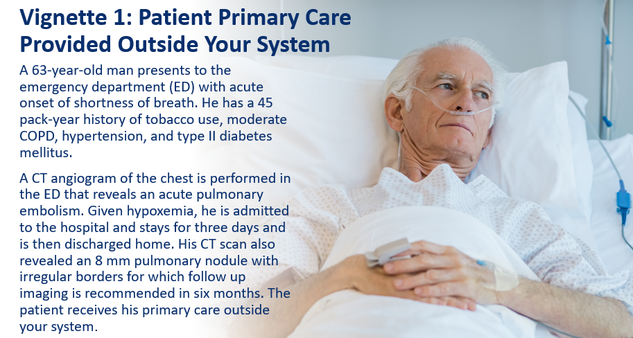
  - Who are the key participants that need to be involved in patient follow-up?
  - How likely do you think it is that the acute care team members are aware of the nodule?
  - How likely do you think it is (in present state) that the nodule and need for follow-up will be shared with the patient?
  - Who is notified of the nodule at the time of discharge?
  - How will the acute care providers, or other appropriate providers, be made aware if proper follow-up doesn’t occur?
  - What system(s) exist to ensure that proper follow-up occurs?
  - How would this differ if the patient’s primary care provider is in the system? What if they had no primary care provider?
  - List the sources and resources you would need to contact to receive the answers to these questions.
  - Which sources and resources listed are missing from the processes at your institution?

Vignette 1: Summary Questions
  - What common problems were identified in the vignette?
  - What gaps were identified in your institution’s processes while working through this vignette?
(Keep these gaps in mind. The final activity of this project is to develop a plan to address gaps.)

Vignette 2: Referred to Internal Medicine
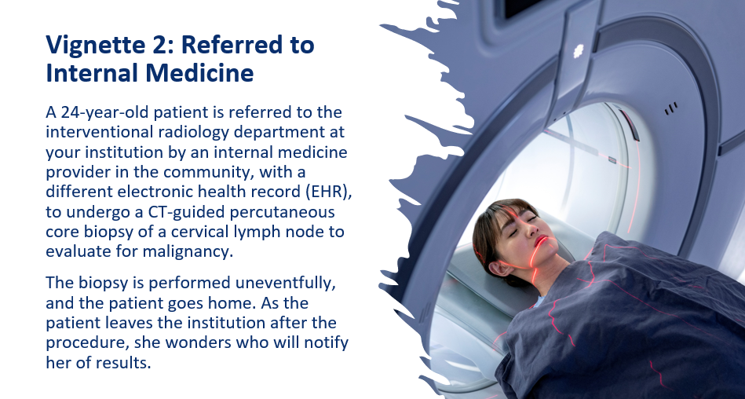
  - How does the communication of results differ if the biopsy is positive or negative? Should it?
  - How, and to whom, are these results communicated?
  - What systems are in place to ensure that appropriate follow-up has occurred?
  - Who is responsible for ensuring this follow-up and communication have occurred?

Vignette 2: Summary Questions
  - What common problems were identified in the vignette?
  - What gaps were identified in your institution’s processes while working through this vignette? (Keep these gaps in mind. The final activity of this project is to develop a plan to address gaps.)

Vignette 3: Toddler in Emergency Department
  - Who would receive the information about this elevated creatinine level? How would it be transmitted?
  - How likely do you think it is that the family would receive this information?
  - How would follow-up systems differ if the patient does or does not receive primary care within your health system? What if the patient has no primary care provider?
  - What systems are in place to ensure that follow-up occurs?

Vignette 3: Summary Questions
  - What common problems were identified in the vignette?
  - What gaps were identified in your institution’s processes while working through this vignette? (Keep these gaps in mind. The final activity of this project is to develop a plan to address gaps.)

Vignette 4: Pending Labs After Discharge
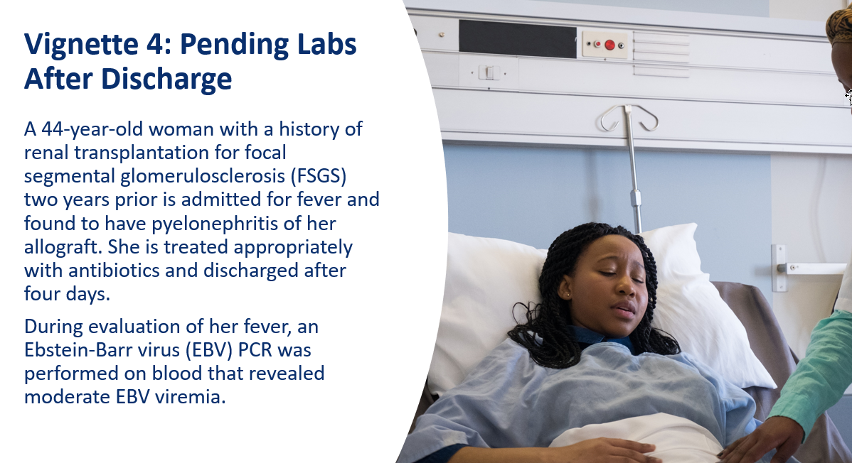
  - Will the information about the EBV viremia be in the discharge summary?
  - How likely do you think it is that the patient would receive this information?
  - Who is responsible for arranging appropriate follow-up testing?
  - Who would be notified if follow-up does not occur?

Vignette 4: Summary Questions
  - What common problems were identified in the vignette?
  - What gaps were identified in your institution’s processes while working through this vignette? (Keep these gaps in mind. The final activity of this project is to develop a plan to address gaps.)

Activity Three: Conduct Institutional Inventory: Current Communication Processes and Practices

Purpose and Goal
The purpose of this institutional self-assessment tool is to identify:
- Practices and protocols in place to support communication best practices.
- Effectiveness of current practices.
- Individualized strategies to address potential safety gaps not directly covered by existing practices and protocol.
Systematically evaluating successes and failures enables identification of strategies to improve the communication processes across the institution.
The institutional self-assessment focuses on uncovering information in the following areas:
- Current practices.
- Areas of success.
- Potential problem areas.
- Areas targeted for improvement.
Note: It may be useful to refer back to the discussions surrounding the vignettes and the communication gaps that were identified.

Seven-Step Process
As you complete each of the seven steps of this institutional self-assessment exercise, it is vital to analyze how the policies of your health care system may affect patients in disparate ways, depending on factors such as race, gender, age, sexual orientation, and socioeconomic status.
It’s also important to analyze patterns of patients’ use of online portals and messaging systems to assess whether certain patient groups are using these resources. Look for factors such as demographic differences in portal use to help assess the need for engaging with different groups of patients regarding their communication preferences.

Step 1: Identify the Assessment Team
The core team may be involved in all the steps of the activity. However, other stakeholders and subject matter experts may need to be involved on an ad hoc basis.
Follow-up of laboratory and radiology results is a complex process that involves many stakeholders. It may be impossible to get all involved parties in the same room or virtual meeting at the same time.
Because of different roles at each individual institution, there is no single correct way to assign responsibilities to your group members.
In selecting your team, you may find the DACI responsibility matrix a useful tool as you identify personnel, assign tasks, and organize the efforts of your multidisciplinary team. The DACI model acronym stands for driver, approver, contributor, and informed, giving each a different role:
- Driver: The leader of the overall project who determines the direction of the team.
- Approvers: One or more individuals who make project decisions.
- Contributors: Subject matter experts who provide information and resources.
- Informed: Individuals to be kept up to date on progress but who do not have responsibilities for decisions or tasks.
For more information, refer to “What Is DACI: an Explainer.”

Roles and Services to Consider Including in the Assessment Team
- Assessment leader
- Patient representative
- Resident
- Fellow
- Medical student
- Pathology and laboratory medicine
- Radiology (diagnostic and interventional)
- Inpatient hospital medicine
- Inpatient subspecialty services
- Outpatient primary care and subspecialty clinics
- Emergency medicine services
- Risk management/legal services
- Care coordinators/navigators
- Health information technology

Involve Trainees
Because trainees are often the most directly involved in day-to-day operations, they can provide critical insight into current practices and may provide ideas for innovation and improvement. Participation in this assessment, as well as in the entire improvement process, provides trainees an opportunity to become engaged at an early stage in their career.
Note: In working with trainees, consider using the checklist below as a fact-finding tool to assess communication practices among learners at your institution. Program directors can think of incorporating this exercise into existing educational conferences such as Morning Report or Noon Conference.

Step 2: Recognize and Discuss Current Successes
Before delving into the shortcomings and gaps, it can be helpful to focus on the positive by identifying highly reliable systems within your institution and determining which practices have been effective for follow-up of laboratory and radiologic abnormalities.
For example, if the radiology department has been highly successful in follow-up of incidental lung nodules, examine the successful protocol to answer the following questions:
- What is the workflow for communicating results?
- Are there any factors that make this process uniquely successful?
- What resources does this require?
- What aspects of the successful practice could be applied to other patient scenarios?
For a more structured approach to identifying successes, consider using Appreciative Inquiry, a philosophy of relationship-building and problem-solving.
The Appreciative Inquiry model uses a five-phased approach to exploring the situation: Defining, discovering, dreaming, designing, and destiny (or deploying).
During these phases, participants first specifically define the topic at hand that needs to be addressed. Then they discover what is working well, dream of ways to make it even better, and finally, design implementation of a final solution. This approach can take minutes, hours, or even longer, depending on the depth of the conversations.
The model flips the focus from what isn’t working to what is working, and how to build on that. By highlighting the positives of a situation or relationship, stakeholders are energized, responses are constructive, and confidence in a strategy for moving forward becomes mutual.
A variation of the full Appreciative Inquiry model is to streamline the process into about one hour by using a series of interviews. Liberating Structures adapted the five-phased approach by adding more organization to each phase with targeted interview-style questioning and incorporating more structure to the inquiry exercises.

Step 3: Document Legal and Accreditation Requirements
- What accrediting bodies are in place that address potential gaps in communication identified throughout this project so far?
(These may include but are not limited to: Joint Commission; College of American Pathology; American College of Radiology; State requirements; federal regulations, including the Centers for Medicare & Medicaid Services.)
- What are some of the reasons policies may or may not be followed on a routine basis?
In this section, participants will evaluate existing legal and accreditation requirements that address potential communication gaps. Consider questions such as:
For each clinical care team (e.g., general medicine, surgery, cardiology, etc.) or clinical service group (e.g., laboratory, radiology) responsible for acute care of patients, consider asking a designated representative to compile the checklist below.
This task needs to be completed apart from and prior to an in-person or virtual discussion.

Step 4 Categorize Results
Diagnostic results may fall into the following categories: abnormal critical, abnormal non-critical requires follow-up, abnormal non-critical follow-up not required, normal. For each result category, ask the designated representatives from each service to determine the following, as they currently exist:
- Which results fall into each category for your service and/or practice.
- An acceptable time frame for follow-up.
- Where the time frame for follow-up is documented.
- Acceptable methods of notification (e.g., letter, phone call, office visit) for each category.
- Who may receive these results.
- How soon the information is available to patients via portal and/or medical record.
- Escalation procedures in place to ensure follow-up.
A sample table is provided below. This step is also completed as homework, keeping in mind that these are examples only and are not intended to be a comprehensive list. Note: NA (not applicable) is an acceptable answer.
Categorizing Patient Results
Team members:
Clinical service:
Escalation procedures:
Category | Example: Types of Results | Time Frame for Follow-Up | Time Frame for Documentation | Notification Method | Who Is the Notifier? | Who Is the Notifyee? | How Is This Notification Documented?
Abnormal Critical
Abnormal Non-Critical Requires Follow-Up
Abnormal Non-Critical Follow-Up Not Required
Normal

Step 5: Identify Communication Practices for Various Follow-Up Scenarios
The type of communication follow-up required will differ depending on the patient scenario.
For example, a hospital patient without an established primary care provider being discharged with multiple pending laboratory and radiology tests will require more intensive communication follow-up than an outpatient who had an imaging study ordered by their established primary care provider.
Identify one or more of the following patient scenarios for which your institution has established communication follow-up protocols. There is space in the table to add a case scenario you consider significant.
Diagnostic Follow-Up Scenario | Established Protocol? | Type of Communication Required
Inpatient transferred to a different inpatient service in the same hospital. | ☐ Y ☐ N
Inpatient transferred from another hospital or health care system to the AMC. | ☐ Y ☐ N
Inpatient transferred from the AMC to another hospital or health care system. | ☐ Y ☐ N
Patient being discharged from inpatient or emergency department:
- Primary care provider or responsible specialist within the same health care system. | ☐ Y ☐ N
- Primary care provider or responsible specialist outside the health care system. | ☐ Y ☐ N
- No primary care provider or responsible specialist identified. | ☐ Y ☐ N
Patient presenting for specialized testing ordered by another provider (e.g., bronchoscopy or biopsy by interventional radiology) in the health system. | ☐ Y ☐ N
Patient presenting for specialized testing ordered by another provider (e.g., bronchoscopy or biopsy by interventional radiology) outside the health system. | ☐ Y ☐ N
[Add your own scenario] | ☐ Y ☐ N

Step 6: Document Communication Practices and Procedures
In the previous step, you were asked to inventory communication practices for different patient scenarios. It is also important to have written procedures in place. Copy the communication practices you identified in Step 5 into the table below, and identify the who, when, and how for each practice or procedure.
Documenting Your Existing Communication Practices
Type of Communication Practice or Procedure | Who should receive the communication? | When should communication be sent? | How is the communication accessed?* | How is communication loop closed and documented?
*Examples of access methods: email, patient portal, telephone, and text.
Using Patient Portals
How does your system document and ensure that results provided via portal are accessed by the patient?

Step 7: Determine the Level of Institutional Support
It is not enough to simply have the proper communication practices and procedures in place. It is also vital to make sure the system is designed to support the execution of best practices. Consider if your facility supports and encourages effective communication and continuity of care through the following practices.
Institutional Support for Communication Best Practices
Practice or Procedure | Type of Support Provided
Designated individuals are assigned for follow-up of abnormal laboratory/imaging results in these situations:
- Discharge from the emergency department.
- Discharged inpatients.
Dedicated time is provided for communicating and documenting follow-up for results.
Staff and providers who demonstrate best practices in communication and patient safety are rewarded (e.g., a “Good Catch” award).
A system is in place to report and analyze patient safety events related to failures in communication.
[Add your own]

Activity Four: Reflection and Action Guide

Reflect Upon Your Work Thus Far
After you’ve gathered information from the previous activities, review the following sources to help you identify and document communication gaps. Use the questions and space below to summarize your group’s work so far.
Vignettes – For each of the vignettes you discussed, review the summary questions and aggregate the responses:
What common problems were identified across the vignettes?
What gaps were identified in your institution’s processes?
Refer to the following sections in “Institutional Inventory: Current Communication Processes and Practice”:
- "Step 5: Identify Communication Practices for Various Follow-Up Scenarios" — List the scenarios where there is no established communication protocol or where a communication gap exists. Describe the gap in the second column below.
- For more information, refer to "Step 6: Document Communication Practices and Procedures."
Scenario Description | Communication Gap (who, when, how)
"Step 7: Institutional Support for Communication Best Practices" — List the practice or procedure where support is inadequate or lacking.

Develop an Action Plan
- List three high priority communication gaps you have identified, and rank them by importance.
- Choose one to act upon immediately.
- List specific steps to begin closing the gap.
- Develop and document a plan to monitor progress and project success.
Use this information to feed into your institution process improvement infrastructure.
High Priority Communication Gaps
Gap 1:
Gap 2:
Gap 3:
High Priority Communication Gap to Act Upon
Steps to Take to Address Communication Gap

Appendix A: Trainees Fact-Finding Tool
Procedure (if any) for trainees to be notified of results on their patients after an episode of care for the following settings:
Inpatient service
Outpatient service
Emergency department
Procedure (if any) for trainees to be notified of results after they have completed their rotation and moved to a different service:
Procedure for handoffs when completing a rotation regarding pending diagnostic testing information:
Who has the ultimate responsibility for trainee ordered tests? How is that person notified of pending tests done under their supervision as well as test results?
Trainee awareness of existing policies and practices for onboarding:
Do trainees receive formal didactic training on the following subjects?
- Evidence-based follow-up of abnormal laboratory and radiology findings.
- Discharge planning with respect to diagnostic information.
- Handoffs for diagnostic information.
- Communication strategies for diagnostic information.

