

**AAMC GSA PDI:   
Goal Development and Execution Guide**

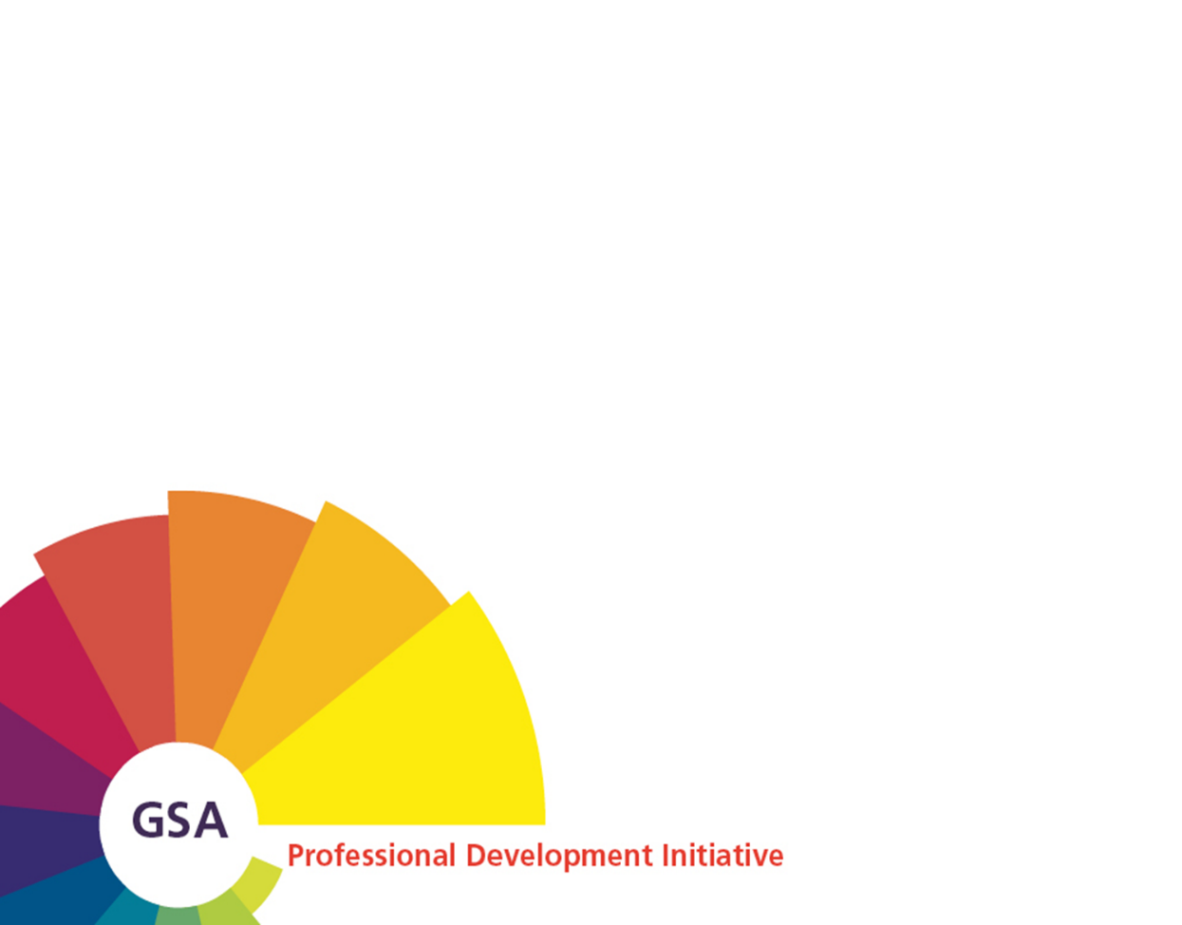

Background

The intent of this document is to provide an overview of the GSA performance framework as part of the GSA Professional Development Initiative. For further information on the Initiative and available support, go to [www.aamc.org/gsapdi](http://www.aamc.org/gsapdi) and/or send a message to [GSApro-develop@aamc.org](mailto:GSApro-develop@aamc.org).

Acknowledgments

The AAMC extends its appreciation to all those who participated in producing this publication. In particular, we thank the current and former members of the GSA Professional Development Initiative Advisory Group for their dedication and guidance. We also acknowledge STS Human Resource Consulting, as an acting member of the AAMC’s Learning, Leadership Development, and Evaluation team. Their contributions were instrumental in facilitating the evolution of the Initiative and development of the validated GSA Framework and associated documentation and tools.

© 2016 Association of American Medical Colleges. May not be reproduced without permission

This is a publication of the Association of American Medical Colleges. The AAMC serves and leads the academic medicine community to improve the health of all. [www.aamc.org](http://www.aamc.org).

For more information about this publication, please email [GSApro-develop@aamc.org](mailto:GSApro-develop@aamc.org).

Association of American Medical Colleges

655 K Street, NW, Suite 100

Washington, DC 20001

This guide is organized in key sections to help you, a GSA professional, **discuss and define** your professional development goals. It can serve as a valuable resource as you think about and develop your professional development goals, prepare to discuss them with your supervisor, mentor or other trusted colleague, and plan how you will achieve them.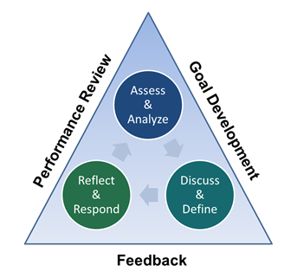

# Goal Overview

A goal is an outcome that an individual or group of individuals envisions, plans, and commits to achieve. Goals may be short-term or long-term and may be created for a variety of reasons, including to:

1. **Drive Performance** – the focus is on addressing a skill, a performance gap, or a specific performance issue.
2. **Maximize Talent and Contributions** – the focus is on achieving potential within one’s current role, or the focus may be on contributing to a specific priority within your organization. This may position a professional for the next opportunity, role, or job posting.
3. **Achieve Aspirations** – the focus is on advancing one’s own personal career development.

Types of goals fall into two categories:

## **Performance Goals**

## These are generally short term, and consist of specific tasks or responsibilities associated with your current role. They usually relate to your position description or critical behaviors, or they may be goals that contribute to the organizational goals where you work. Because they are often used as benchmarks for success, performance goals should be clearly defined and easy to measure. They answer the question:

*“*What can I do in my current position to build my capabilities and   
increase contributions to my organization?”

## **Personal Goals**

These are short or long-term and should align with your specific talents, interests, and career aspirations. They answer the question:

*“What can I do in my current position to build my capabilities to   
move my career in the direction I want to go?”*

**GOAL DEVELOPMENT**

Effective goals should be written in way that answers three key questions:

|  |  |  |
| --- | --- | --- |
| Where should I focus? | How will I know I’m successful? | How will I get there? |

Goals must be defined clearly and comprehensively. Utilize the **SMART** guidelines below to ensure that your goals are appropriately targeted and meaningful, and have clear measures that define success.

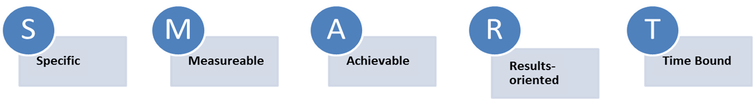

**Specific.** Goals should be detailed, unambiguous, and focused. A goal is specific when everyone knows exactly what is to be achieved and accomplished. It does not include generalizations or vague language like “improve communications, increase effectiveness, or maximize contributions.”

**Measurable.**  Goals should contain quantitative or qualitative indicators. A goal is measurable when it has a method for comparison that indicates when the goal is reached. For example, “complete by 3rd quarter end, increase by 25%, or give three presentations within the next two months.”

**Achievable.** Goals should be practical, realistic, and possible. A goal is attainable when it falls within the professional’s area of responsibility or control. It may be a “stretch” goal that is more challenging and reaches beyond what is easily achieved. Refer to the benchmarks within the GSA Performance Framework to help you identify an appropriate level of complexity and reach.

**Results-oriented**. Goals should be written to include an action verb to describe the specific type of activity required to produce the desired result. For example, evaluate, develop, investigate, influence, enhance, appraise, implement, revise, etc.

**Time Bound.** Goals should be performed and/or accomplished within a designated timeframe. An action plan should be developed that includes a schedule of milestones and a target date for completion. See examples noted under “Measurable.”

When developing your goals you are encouraged to:

* Reflect on your performance, what’s expected of you, and what you want to achieve – in your current role, and in alignment with your career aspirations and interests
* Consider opportunities to contribute in support of department, school, and community priorities
* Balance your performance and personal goals, aiming to develop between 2-4 total goals or whatever the number that is recommended by your school
* Engage your supervisor, mentor, and/or trusted colleagues for insights, affirmation, and support

**GOAL EXECUTION**

After collaborating with your supervisor or mentor in identifying your SMART goals and an action plan that includes milestones and a target completion date, consider the following recommended activities:

1. **Identify and secure specific development opportunities**, such as a performing a new task or project role, or attending a workshop or virtual event in order to gain the appropriate knowledge, skills, and experiences required to achieve your goals.
2. **Identify required resources and support to implement your plan**, keeping in mind potential roadblocks and barriers you may face along the way.
3. **Communicate your goals to key people** who will advocate and help you obtain needed resources, appropriate opportunities and experiences.
4. **Make an agreement with your supervisor or mentor** as to how you will stay connected formally and informally to make sure you are successful.

The following GSA Goal Development Worksheet may be helpful in writing your goals, developing an action plan, and identifying other key factors that may impact your ability to achieve the results you want. It can also serve as a focal point for your ongoing professional development discussions.

On the Worksheet, you will notice a field titled *GSA Framework Alignment,* which you can use to align your goals with the Common Areas and Areas of Expertise within the [GSA Performance Framework](https://www.aamc.org/download/433980/data/gsaperformanceframeworkdetail.pdf). Alternatively, if your organization has defined competencies or values, feel free to use those instead.

|  |  |  |  |
| --- | --- | --- | --- |
| **GOAL #1 Description**  (Review SMART goal components) | **GSA Framework Alignment**  (Refer to critical behaviors and benchmarks) | **Rationale**  (Explain why this goal  is important) | |
| Click here to enter your goals. | Click here to enter one or more behaviors that the goal aligns with. | Click here to explain why you selected this goal. | |
| **Measures that Define Desired Outcome** (Quantitative and/or qualitative measures that demonstrates progression and achievement) | | | |
| Click here to enter criteria for success. | | | |
| **Requirements for Success** (Support and resources needed) | | | |
| Click here to enter resources and support needed. | | | |
| **Potential Challenges** (Potential roadblocks or impediments you may encounter along the way) | | | |
| Click here to enter roadblocks or impediments. | | | |
| **Milestones** (Activities needed to accomplish your goal) | | | **Target Date for Completion** |
| Click here to enter your action steps or activities. | | | Click here to enter a date. |
| Click here to enter your action steps or activities. | | | Click here to enter a date. |
| Click here to enter your action steps or activities. | | | Click here to enter a date. |
| Click here to enter your action steps or activities. | | | Click here to enter a date. |

|  |  |  |  |
| --- | --- | --- | --- |
| **GOAL #2 Description**  (Review SMART goal components) | **GSA Framework Alignment**  (Refer to critical behaviors and benchmarks) | **Rationale**  (Explain why this goal  is important) | |
| Click here to enter your goals. | Click here to enter one or more behaviors that the goal aligns with. | Click here to explain why you selected this goal. | |
| **Measures that Define Desired Outcome** (Quantitative and/or qualitative measures that demonstrates progression and achievement) | | | |
| Click here to enter the criteria for success. | | | |
| **Requirements for Success** (Support and resources needed) | | | |
| Click here to enter resources and support needed. | | | |
| **Potential Challenges** (Potential roadblocks or impediments you may encounter along the way) | | | |
| Click here to enter roadblocks or impediments. | | | |
| **Milestones** (Activities needed to accomplish your goal) | | | **Target Date for Completion** |
| Click here to enter your action steps or activities. | | | Click here to enter a date. |
| Click here to enter your action steps or activities. | | | Click here to enter a date. |
| Click here to enter your action steps or activities. | | | Click here to enter a date. |
| Click here to enter your action steps or activities. | | | Click here to enter a date. |

|  |  |  |  |
| --- | --- | --- | --- |
| **GOAL #3 Description**  (Review SMART goal components) | **GSA Framework Alignment**  (Refer to critical behaviors and benchmarks) | **Rationale**  (Explain why this goal  is important) | |
| Click here to enter your goals. | Click here to enter one or more behaviors that the goal aligns with. | Click here to explain why you selected this goal. | |
| **Measures that Define Desired Outcome** (Quantitative and/or qualitative measures that demonstrates progression and achievement) | | | |
| Click here to enter the criteria for success. | | | |
| **Requirements for Success** (Support and resources needed) | | | |
| Click here to enter resources and support needed. | | | |
| **Potential Challenges** (Potential roadblocks or impediments you may encounter along the way) | | | |
| Click here to enter roadblocks or impediments. | | | |
| **Milestones** (Activities needed to accomplish your goal) | | | **Target Date for Completion** |
| Click here to enter your action steps or activities. | | | Click here to enter a date. |
| Click here to enter your action steps or activities. | | | Click here to enter a date. |
| Click here to enter your action steps or activities. | | | Click here to enter a date. |
| Click here to enter your action steps or activities. | | | Click here to enter a date. |