

AAMC GSA PDI:
Performance Reflection and Assessment Guide

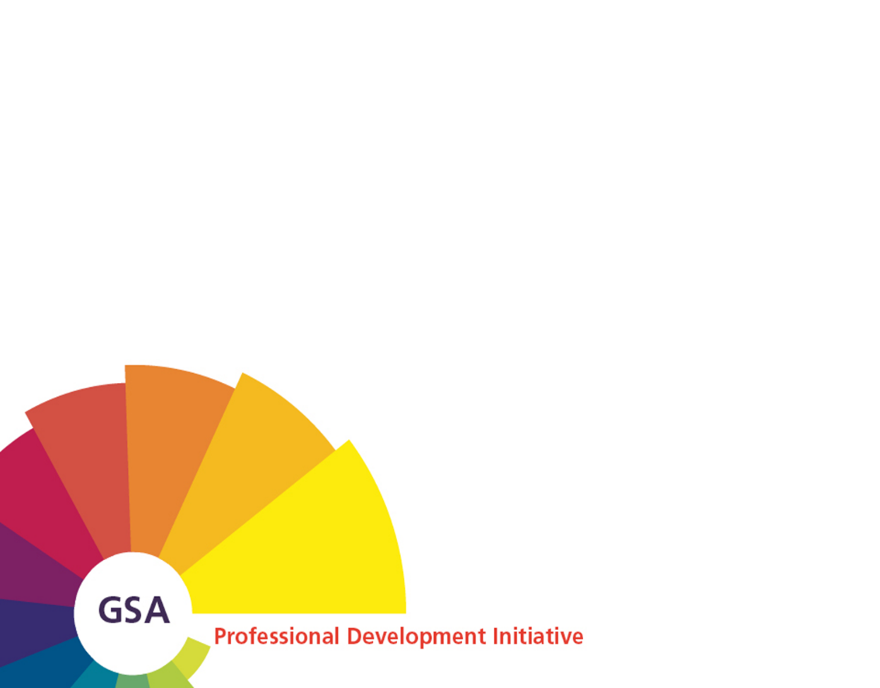

Background
The intent of this document is to provide an overview of the GSA performance framework as part of the GSA Professional Development Initiative. For further information on the Initiative and available support, go to www.aamc.org/gsapdi and/or send a message to GSApro-develop@aamc.org.
Acknowledgments
The AAMC extends its appreciation to all those who participated in producing this publication. In particular, we thank the current and former members of the GSA Professional Development Initiative Advisory Group for their dedication and guidance. We also acknowledge STS Human Resource Consulting, as an acting member of the AAMC’s Learning, Leadership Development, and Evaluation team. Their contributions were instrumental in facilitating the evolution of the Initiative and development of the validated GSA Framework and associated documentation and tools.

© 2016 Association of American Medical Colleges. May not be reproduced without permission

This is a publication of the Association of American Medical Colleges. The AAMC serves and leads the academic medicine community to improve the health of all. www.aamc.org.

For more information about this publication, please email GSApro-develop@aamc.org.
Association of American Medical Colleges
655 K Street, NW, Suite 100
Washington, DC 20001

Table of Contents
Performance Reflection and Assessment – The 5-Step Process 1
Incorporating the GSA Performance Framework into the 5-Step Process 1
Prepare for the 5-Step Process 1
Step 1: Confirm What Is Expected of You 2
Step 2: Conduct a Self-Assessment against Overall Performance Expectations 2
Step 3: Review and Collect Additional Performance Data and Feedback 3
Step 4: Assess Data in Comparison to Overall Performance Expectations 3
Step 5: Develop Your Point-of-View 3
Areas of Expertise (AoE): 4
Common Areas: 5
Assessment Insights and Summary 6
Career Aspirations 7
Potential Development Opportunities 7

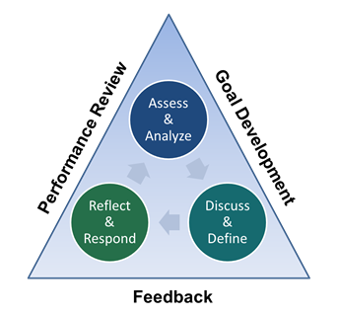
This guide is designed to help you, as a GSA professional, assess and analyze your current capabilities, performance, interests, and future career aspirations. It can serve as a valuable resource as you prepare to discuss and define goals with your supervisor, mentor, or other trusted colleague.

Performance Reflection and Assessment – The 5-Step Process
In general, professionals in most organizations are encouraged to reflect on and assess their performance annually as part of a formal performance management process. This process may consist of formal and informal touch-points throughout the year, determined by your relationship with your supervisor, and guidelines set by your organization. The key activities recommended for professionals to maximize the professional development processes consist of five main steps:
Step 1: Confirm what is expected of you. Review the behaviors critical to perform your role and responsibilities successfully.
Step 2: Conduct a self-assessment against overall performance expectations. Reflect on your current capabilities and behaviors in comparison to overall performance expectations established in Step 1.
Step 3: Review and collect additional performance data and feedback. Review all performance data and feedback collected from other sources (e.g., peers, supervisors, work results).
Step 4: Assess data against overall performance expectations. Document trends and themes related to your current capabilities and behaviors in comparison to your overall performance expectations.
Step 5: Develop a point-of -view. Build a perspective of your capabilities and potential professional development needs, taking into consideration the data and feedback you gathered from others, as well as your interests and future aspirations.

Incorporating the GSA Performance Framework into the 5-Step Process
The GSA Performance Framework is a validated tool that you can use throughout the five step process, in conjunction with your position description, school values, competencies, and other documentation.
The Framework was developed to complement and enhance professional development practices across the GSA community. It sets a clear and consistent benchmark of performance excellence, by specifying essential critical behaviors for all roles across student services, in alignment with relevant LCME standards.

Prepare for the 5-Step Process
To best incorporate and benefit from the Framework:
- Review the GSA Performance Framework Overview.
- Review and print a copy of the GSA Performance Framework, keeping in mind the following points:
- Benchmarks are progressive – The benchmarks within each Area of Expertise (AoE) or Common Area provide the foundational building blocks to progress to the next benchmark. For example, if Benchmark 2 is selected, it is assumed that you are able to perform Benchmark 1.
- Multiple areas and multiple benchmarks may be selected – For example, in a given Area, you may select Benchmark 1 for one behavior, and you may identify a few behaviors under Benchmark 2. Depending on the work you perform, you may also select different benchmarks for different Areas.
- Critical behaviors may be modified – Based on your school’s priorities and what they deem as essential critical behaviors, you may want to add or remove certain ones to further clarify behavioral expectations specific to your role.

Step 1: Confirm What Is Expected of You
The Framework, which consists of the essential behaviors to successfully perform your current role and responsibilities, can be useful in confirming overall performance expectations. With the Framework in hand, identify your appropriate benchmark(s) and/or behaviors in the context of your current role and responsibilities:

  - Select Areas of Expertise – select one or more AoEs that most closely align with your current role and responsibilities.
Choose Benchmarks – within each of your selected AoEs, review the behaviors associated with each of the three benchmarks, and circle the single benchmark that most closely represents the behaviors that are expected to perform your job.
- Use the AoE table on page 4 to select your AOEs and the appropriate benchmark for each AOE
  - Select Benchmarks for Common Areas – for all Common Areas, review the behaviors associated with each of the three benchmarks, and circle the single benchmark that most closely represents the behaviors that are expected to perform your job.
(Note: Common Areas are relevant to all GSA professionals, no selection is necessary.)
- Use the Common Areas table on page 5 to select the appropriate benchmark for each Common Area
  - Meet with Your Supervisor – if possible, this step is helpful to confirm a shared understanding of your overall performance expectations.

Step 2: Conduct a Self-Assessment against Overall Performance Expectations
The behaviors that are expected of you in your current position serve as the measure against which you self-assess your current capabilities and performance.
This is your opportunity to develop your own perspective on how you are doing in comparison to what is expected of you, independent of data and feedback provided by others.
With the Framework in hand, continue using the Areas of Expertise table on page 4 and the Common Areas table on page 5, and note the following:
- Strengths –Behaviors in which you believe you consistently exceed expectations.
- On-target – Behaviors in which you consistently meet expectations.
- Gap/Deficit – Behaviors in which you inconsistently exhibit or fail to exhibit.

Step 3: Review and Collect Additional Performance Data and Feedback
Confirm that you have data and feedback from other sources to support your perspective that you established in Step 2. Collect additional data if needed.

Step 4: Assess Data in Comparison to Overall Performance Expectations
Look for trends in your performance data and feedback, and compare it to the behaviors expected of you as established in Step 1. Again, use the Strengths, On-Target, and Gap/Deficit portion of the Areas of Expertise table on page 4 and the Common Areas table on page 5, and add your findings from other data sources to get a complete picture of your performance, noting where consistencies and differences exist.

Step 5: Develop Your Point-of-View
Now, it’s time to develop a point-of-view on your performance based on your self-assessment, and the data and feedback you gathered from others.
- Using the insights gained by completing Steps 1-4 above, answer the questions in the Assessment Insights and Summary on page 6.
- With the Framework in hand, think about your career more broadly and answer the questions in the Career Aspirations section on page 7.
After reviewing your answers in the Career Aspirations section, identify and document potential development opportunities and key questions in the Potential Development Opportunities section on page 7 to discuss with your supervisor or mentor.

Areas of Expertise (AoE):
Strength  Capabilities and behaviors in which you consistently exceed expectations when performing your work. | On-Target  Capabilities and behaviors in which you consistently meet expectations when  performing your work. | Gap/Deficit  Capabilities and behaviors in which you inconsistently or fail to meet expectations when performing your work.
Selected AoE: Choose an AoE from Drop-list. Benchmark: Choose a Benchmark from Drop-list.
Click here to enter your strengths. | Click here to enter your on-target behaviors. | Click here to enter areas for improvement.
Selected AoE: Choose an AoE from Drop-list. Benchmark: Choose a Benchmark from Drop-list.
Click here to enter your strengths. | Click here to enter your on-target behaviors. | Click here to enter areas for improvement.
Selected AoE: Choose an AoE from Drop-list. Benchmark: Choose a Benchmark from Drop-list.
Click here to enter your strengths. | Click here to enter your on-target behaviors. | Click here to enter areas for improvement.

Return to Step 1
Return to Step 2
Return to Step 4

Common Areas:
Strength  Capabilities and behaviors in which you consistently exceed expectations when performing your work. | On-Target  Capabilities and behaviors in which you consistently meet expectations when  performing your work. | Gap/Deficit  Capabilities and/ behaviors in which you inconsistently or fail to meet expectations when performing your work.
LEADERSHIP Benchmark: Choose a Benchmark from Drop-list.
Click here to enter your strengths. | Click here to enter your on-target behaviors. | Click here to enter areas for improvement.
ORGANIZATIONAL ACUMEN Benchmark: Choose a Benchmark from Drop-list.
Click here to enter your strengths. | Click here to enter your on-target behaviors. | Click here to enter areas for improvement.
RELATIONSHIPS Benchmark: Choose a Benchmark from Drop-list.
Click here to enter your strengths. | Click here to enter your on-target behaviors. | Click here to enter areas for improvement.
SERVICE Benchmark: Choose a Benchmark from Drop-list.
Click to here enter your strengths. | Click here to enter your on-target behaviors. | Click here to enter areas for improvement.

Return to Step 1
Return to Step 2
Return to Step 4

Assessment Insights and Summary
Using the insights gained by completing Steps 1-4, answer the questions below to help target your strengths and professional development needs in support of your current role and responsibilities.

For areas identified as Strengths, indicate potential opportunities to leverage your strengths to further enhance your performance and increase your contributions.
Click here to enter potential opportunities to leverage your strengths.

For areas identified as On-Target or Gap/Deficit, indicate what you believe hinders your demonstration of more effective performance and capabilities. Consider environmental factors (e.g., lack of direction, resource limitations) and internal factors (e.g., lack of interest or desire, lack of skills or knowledge). Identify specific opportunities to increase your competence and confidence in the areas identified.
Click here to enter hindrances to more effective performance.

Thinking about your current personal and professional development goals and progress, indicate any notable factors (internal and external) that have contributed or hindered your current level of achievement. Also note any specific needs you have (resources, support, etc.) to position you for continued success.
Click here to enter factors that contributed or hindered your level of developmrnt.

Return to Step 5

Career Aspirations
As you prepare for your goal development discussions, consider your long-term career aspirations to help you focus your development. With the Framework in hand, consider the following questions:
Considering your current role and responsibilities:
- What is most engaging and interesting about the work you perform?
- What additional impact and contributions would you like to make?
- What questions would you like to explore to better understand your options?
Click here to enter answers re: your current role and responsibilities.

Considering your longer term career aspirations:
- What additional role and/or activities are you interested in exploring to increase your contributions and engagement within the realm of student affairs role and functions?
- What specific capabilities or experiences would you like to gain, internal and external to student affairs, to further refine your interests and goals?
Click here to enter answers re: your long-term career goals.

Return to Step 5

Potential Development Opportunities
In reviewing your self-assessment, the data and feedback provided by others, and your career aspirations, document the key professional development opportunities you’d like to explore. Be as specific as possible.
- Click here to enter development opportunities.

- Click here to enter development opportunities.

- Click here to enter development opportunities.

- Click here to enter development opportunities.

- Click here to enter development opportunities.

Use the space below to document questions in preparation for discussing your goals, career aspirations, and potential development opportunities.
Click here to enter questions in preparation for your goals discussion.

Return to Step 5

